Bagayas, Kevin

CS-305 Module 5 Certificate Generation

8/4/2024

1. Why would you want to use a CA for security?

-Certificate Authority is a company or organization that acts to validate the identities

of entities (such as websites, email addresses, companies, or individual persons) and binds them to cryptographic keys through the issuance of electronic documents known as digital certificates (SSL Support Team, 2024).

-These are important in order to have a more secure communication, protect against malware, document authentication and verifications. It verifies connections ensuring it comes from a trusted source.

2. What are the advantages of using CA?

-There are many advantages of using CA like having better security standards, public trust and credibility. Also having that extra layer of security verification makes the system more secured. It also gives out information for any revoked certificates that can easily make known that they are untrusted sources. The added security verification of a third party or outside agency makes the process more efficient and trustworthy.

Screenshots:

1. Completed fields of the certificate form

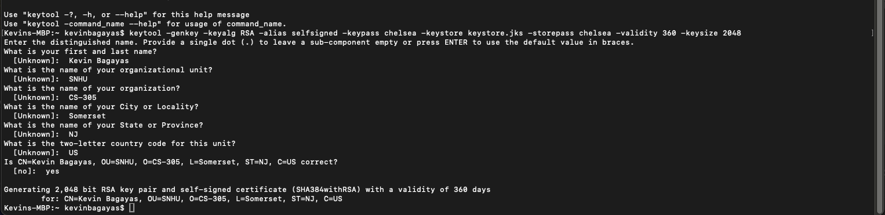

1. Printout of the server.cer file





Sources:

SSL Support Team. (2024, January 5). *What is a Certificate Authority (CA)?* SSL.com. https://www.ssl.com/article/what-is-a-certificate-authority-ca/